THEMENBLOCK 18: Environment & Living Circumstances

CATEGORY A: CONTRASTING IMAGES

TASK SET A1: Water Consumption Culture

Part 1 — Individual Long Turn
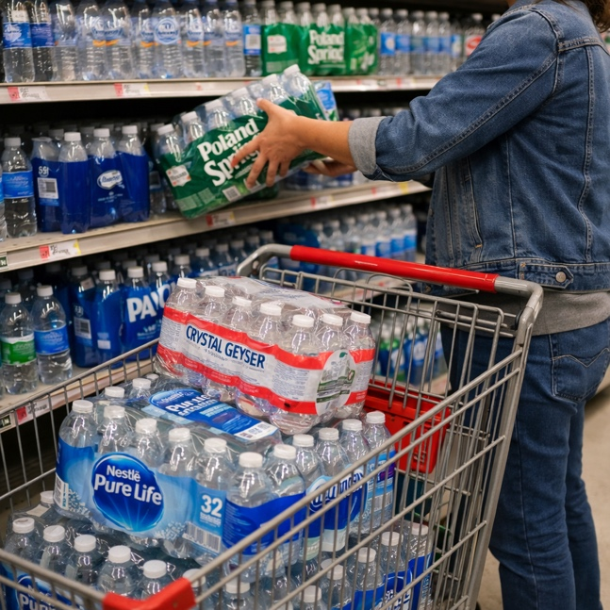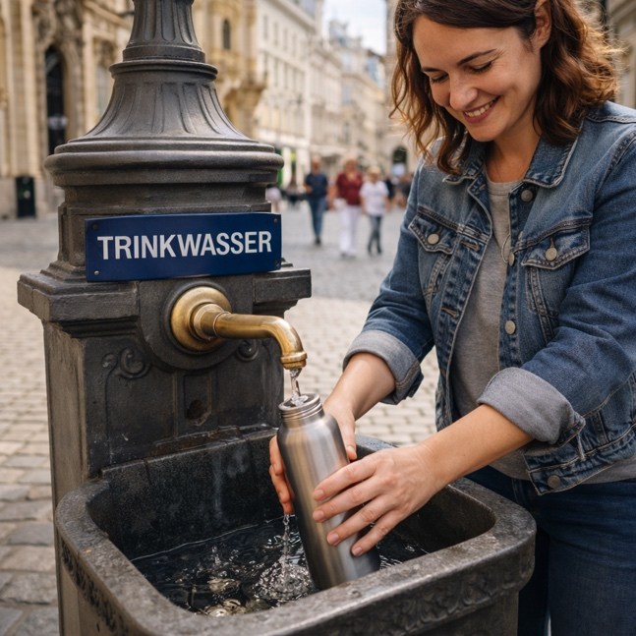

Task: Give a five-minute talk on water consumption and environmental choices in which you
- Describe, compare and contrast the two pictures above.
- Analyze why bottled water remains popular despite environmental concerns.
- Comment on what cultural differences in water consumption reveal about attitudes toward sustainability.

Part 2 — Paired Activity
Task:
Your school wants to launch a 'Plastic-Free Campus' campaign. You and your partner are on the planning committee and need to decide on the focus areas.
Discuss the following campaign elements and agree on THREE to prioritize:
- Installing more water refill stations around the school
- Banning the sale of plastic water bottles in school vending machines and cafeteria
- Providing free reusable bottles to all new students
- Creating educational content about tap water quality and safety
- Partnering with local businesses to offer discounts for customers with reusable containers

TASK SET A2: Living Space and Nature Access

Part 1 — Individual Long Turn
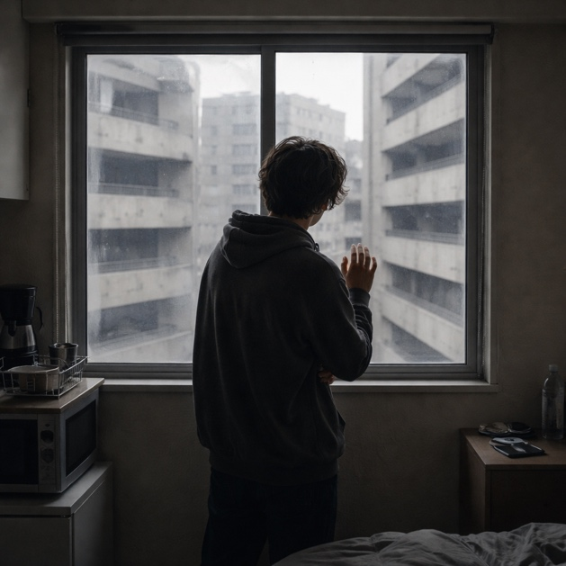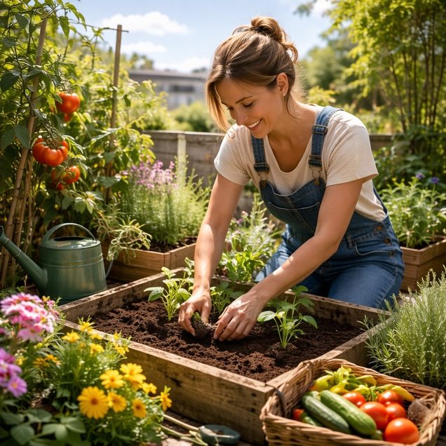

Task:
Give a five-minute talk on housing and access to nature in which you
- Describe, compare and contrast the two pictures above.
- Evaluate the importance of access to outdoor space and nature for physical and mental wellbeing.
- Discuss the trade-offs young people face when choosing where to live.

Part 2 — Paired Activity
Task:
You are working with a young architect who specializes in sustainable design. Together, you need to advise a housing developer on creating apartments that are both affordable AND provide good quality of life.
Discuss and agree on THREE key features to recommend:
- Requiring every unit to have at least a small balcony or terrace
- Creating shared rooftop gardens accessible to all residents
- Designing large windows and high ceilings to maximize natural light
- Building around a central courtyard with trees and plants
- Including indoor 'green walls' and communal plant spaces in the building

TASK SET A3: Tourism Pressure on Natural Spaces

Part 1 — Individual Long Turn
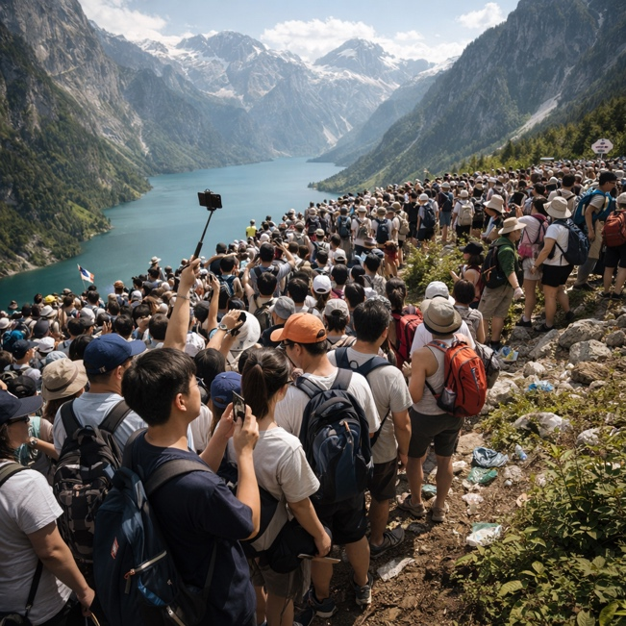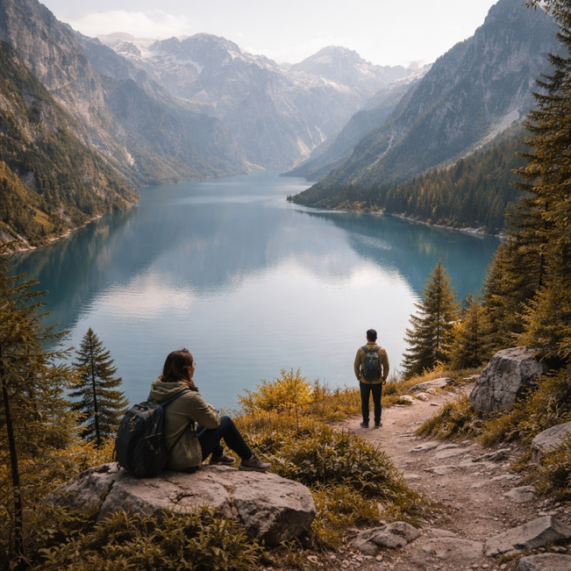

Task:
Give a five-minute talk on tourism and environmental protection in which you
- Describe, compare and contrast the two pictures above.
- Analyze the causes and effects of overtourism on natural spaces
- Discuss possible solutions that balance access to nature with environmental protection.

Part 2 — Paired Activity
Task:
Your regional tourist board wants to develop guidelines for 'Responsible Nature Tourism.' You and your partner have been asked to draft recommendations for visitors.
Discuss and agree on guidelines for these aspects:
- Timing: When should visitors be encouraged to come (season, day of week, time of day)?
- Behavior: What specific behaviors should be promoted or discouraged at natural sites?
- Information: How should visitors be educated about environmental impact before arriving?
- Alternatives: How can lesser-known destinations be promoted without creating new overtourism?
- Enforcement: What consequences, if any, should exist for damaging natural areas?
CATEGORY B: QUOTES

TASK SET B1: Climate Urgency Debate

Part 1 — Individual Long Turn
Quote 1:
"Adults keep saying: 'We owe it to the young people to give them hope.' But I don't want your hope. I don't want you to be hopeful. I want you to panic. I want you to feel the fear I feel every day. And then I want you to act."
— Greta Thunberg, No One Is Too Small to Make a Difference (2019)
Quote 2:
"No one will protect what they don't care about; and no one will care about what they have never experienced."
— David Attenborough, naturalist and broadcaster
Task:
Give a five-minute talk on approaches to climate action in which you
- analyze and compare the two quotes above, explaining the different strategies each suggests.
- evaluate which approach is more effective in motivating climate action.
- comment on what has motivated you or people you know to care about environmental issues.

Part 2 — Paired Activity
Task: Your school is organizing an 'Environmental Action Week.' The planning committee is split between those who want to focus on the urgency of climate crisis and those who want to focus on connecting students with nature.
Take opposing positions (one supports the 'urgency' approach, one supports the 'connection' approach) and debate these aspects:
- What emotions should the week aim to create in students?
- What types of activities best achieve lasting behavior change?
- How do you avoid causing eco-anxiety while still communicating the seriousness of climate change?
- Which approach is more appropriate for different age groups?
- Can both approaches be combined effectively?
Come to a joint recommendation for the planning committee.

TASK SET B2: How Our Living Spaces Shape Us

Part 1 — Individual Long Turn
Quote 1:
"We shape our buildings; thereafter they shape us."
— Winston Churchill, Speech to Parliament (October 28, 1943)
Quote 2:
"Nature is 3.8 billion years ahead of us in research and development."
— Eric Corey Freed, sustainable architect
Task:
Give a five-minute talk on architecture and human wellbeing in which you
- analyze and compare the two quotes above.
- discuss how buildings and spaces affect our behavior, mood, and health.
- comment on what 'learning from nature' might mean for how we design homes, schools, and cities.

Part 2 — Paired Activity
Task:
You have been granted a meeting with your regional Housing Minister to discuss youth concerns about housing quality and sustainability. Before your meeting, you need to prepare.
Discuss these topics and agree on THREE to focus on in your meeting:
- Minimum standards for natural light, ventilation, and green space in new housing developments
- Requirements for energy-efficient building materials and renewable energy systems
- Making sustainable housing affordable for young people and first-time buyers
- Retrofitting older buildings to improve energy efficiency and livability
- Creating mixed-use neighborhoods that reduce car dependency and increase community interaction

CATEGORY C: ALTERNATIVE PROMPTS

TASK SET C1: The European Housing Crisis

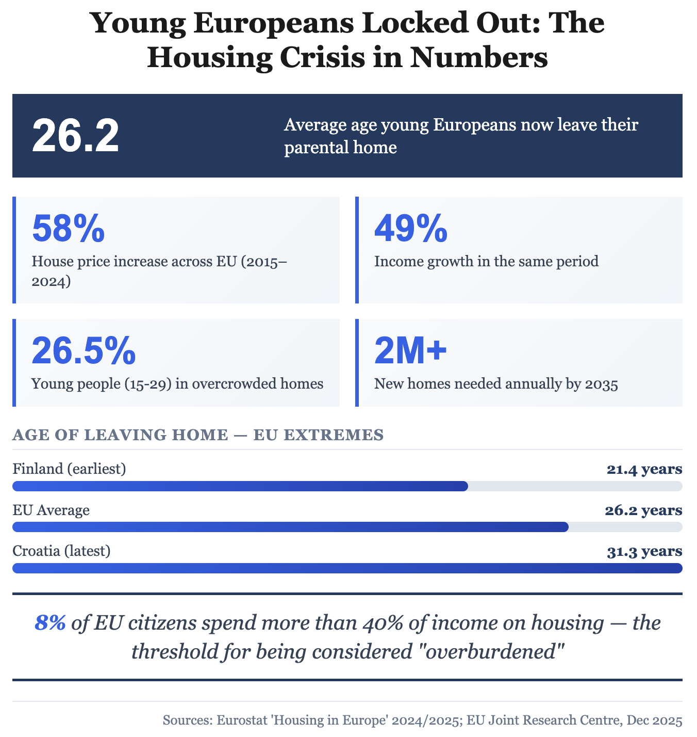
Part 1 — Individual Long Turn
Task: Give a five-minute talk on the European housing crisis in which you
- analyze the statistics and what they reveal about housing challenges facing young people today.
- discuss the causes of this housing crisis and why it particularly affects younger generations.
- comment on what this means for young people's life choices and what solutions might help.

Part 2 — Paired Activity
Task: Your university student union is commissioning research on housing challenges facing students and young graduates. You need to decide on research priorities.
Discuss the following research questions and agree on THREE to prioritize:
- How does housing insecurity affect students' academic performance and mental health?
- What percentage of graduates' income goes to housing in the first five years after university?
- How do housing costs influence young people's decisions about where to work and live?
- What alternative housing models (co-living, intergenerational housing) appeal to young people?
- How effective are current government policies in helping young people access affordable housing?

TASK SET C2: Housing and Climate Impact
Aspect: Buildings and environmental sustainability | Prompt Type: Statistical Overview

Part 1 — Individual Long Turn
Statistical Overview:
BUILDINGS AND THE CLIMATE: KEY EU DATA
Housing represents one of the largest environmental challenges and opportunities in Europe. Buildings account for approximately 36% of EU energy consumption and emissions. In 2024, housing, water, and energy costs made up 23.6% of all household expenditure. Meanwhile, 9% of EU citizens cannot afford to keep their homes adequately warm — rising to nearly 20% in Bulgaria, Greece, and Lithuania. Energy efficiency renovations are uneven: while 18% of people at risk of poverty now live in homes that became more energy efficient in the past five years, those already better off have greater access to green housing improvements.
— Sources: Eurostat 2024; data.europa.eu 'Exploring housing trends with open data'
Task:
Give a five-minute talk on housing and climate change in which you
- analyze the data presented and explain why buildings are so important for addressing climate change.
- discuss 'energy poverty' and why home efficiency is both an environmental and social justice issue.
- comment on what individuals, governments, and the building industry can do to make housing more sustainable.

Part 2 — Paired Activity
Task:
Your local council is offering grants to help homeowners and renters make their homes more energy efficient. You and your partner are helping to design the program.
Discuss the following options and agree on THREE to recommend as priorities for funding:
- Insulation improvements (roof, walls, windows)
- Heat pump installation to replace gas/oil heating
- Solar panel installation on suitable roofs
- Smart thermostats and energy monitoring systems
- Grants specifically for low-income households and renters

